CREATING DYNAMIC, SUSTAINABLE
& THRIVING SPIRITUAL COMMUNITIES
MODULE 2 – Leadership Wisdom, Thriving in Ministry,
Leadership Assessment Tools
Sponsored by Unity Worldwide Ministries Eastern Region

With Church Consultant
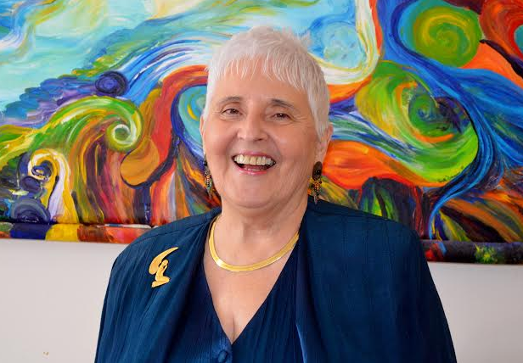
Rev. Pat Bessey
has 21 years of ministry experience; 10 years as a Life Coach; 8 years as church consultant

Are you asking yourself why bring my board and leaders?

- They will learn about creating conscious, effective, and accountable leadership teams
- They will be building capacity for clarity, focus and intentionality
- They will be networking with other area church boards, leaders, and ministers
- They will be sharing “best practices” and leaving with great ideas…
- A follow up coaching conference call with Rev. Pat is available
- AND MUCH MORE…

Saturday, May 5, 2018 from 9:30 – 4:00

Hosted by: Unity Spiritual Center
453 Bellwood Ave
Asbury, NJ
908-730-8792
Cost per ministry: $400.00.
Check to UWMER or you can pay online at www.unityeasternregion.org
R.S.V.P. no later than April 29 to revpatbessey@gmail.com

Lunch and snacks provided for a love offering

