CREATING DYNAMIC, SUSTAINABLE
& THRIVING SPIRITUAL COMMUNITIES

Module 1 – Spiritual Leadership, Ministry Dynamics &
Roles and Accountabilities

Sponsored by Unity Worldwide Ministries Eastern Region

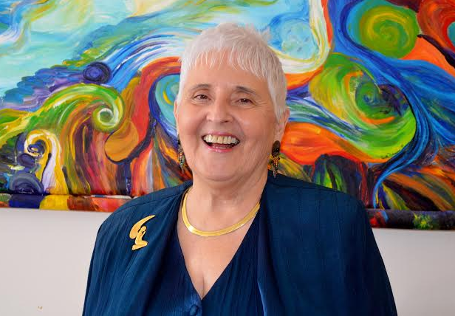
With Eastern Region Church Consultant Rev. Pat Bessey
Pat has 21 years ministry experience; 10 years as a Life Coach; 8 years as Church Consultant

Are you asking yourself why bring my board and leaders?

- They will learn about creating conscious, effective, and accountable leadership teams
- They will be building capacity for clarity, focus and intentionality
- They will be networking with other area church boards, leaders, and ministers
- They will be sharing “best practices” and leaving with great ideas…
- A follow up coaching conference call with Rev. Pat is available
- AND MUCH MORE…
Saturday, April 20, 2018 from 9:30 am – 4:00 pm
Hosted by: Unity of Syracuse
300 W Seneca Turnpike Syracuse, NY
315-492-0330

Cost per ministry: $400.00.
Check to UWMER or you can pay online at www.unityeasternregion.org
R.S.V.P. no later than April 15 to revpatbessey@gmail.com

Lunch and snacks provided for a love offering

